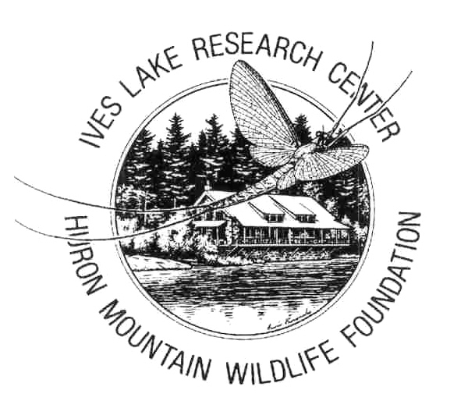
ARTIST-IN-RESIDENCE Opportunity at Research Field Station, northern MI

The Huron Mountain Wildlife Foundation invites applications for a new artist-in-residence program at its Ives Lake Research Center field station.
The Huron Mountain Wildlife Foundation
For 60 years, HMWF has supported field-based natural science research in the Huron Mountains of northern Michigan with a base at its Ives Lake Research Station. Foundation-supported researchers have access to unique and biologically diverse natural areas, including large tracts of old-growth forests, a variety of pristine wetlands and other habitats, and a range of unusual geological features
Currently, the Foundation sponsors around 25 research projects each year, involving scientists from approximately 30 institutions and a dozen states. Projects address aquatic and terrestrial ecology, plant and animal populations and diversity, geology, geochemistry, and hydrology. The Foundation’s website, www.hmwf.org, provides further information.
Artist-in-Residence Program
In 2019, the Foundation hopes to initiate an artist-in-residence program at the Ives lake Research Station. We invite artists interested in producing work informed by the surroundings of the research station and by the work of Foundation-sponsored researchers to apply for residencies of 1-4 weeks from May-September 2019.
What HMWF Provides
HMWF will provide free housing at the Field Station, and reimbursement for travel and subsistence up to $200/week. The Field Station offers ample living and work space that will be shared by researchers and the artist.
The artist will have a private room, but other facilities at the Research Station will be shared with a shifting cast of researchers; it is essential that interested artists be able and willing to work in this environment, with flexible and respectful sharing of facilities (kitchens, bathrooms, etc.).
What HMWF Expects
The Foundation expects that each artist-in residence will a) donate at least one original work to the Foundation, appropriate for its use in publications, exhibit, or fund-raising, b) contribute a short log, journal, or essay for the Foundation’s website (preferably including digital versions of the artist’s work, and c) acknowledge the support of the Foundation as appropriate in showing, publishing, or selling work produced through or directly influenced by the residency.
Artists may work in any medium (subject to some restrictions concerning environmental impact) and works produced during the residency may deal with themes and topics of the artist’s choosing, but HMWF expects that work will somehow show the influence of the local environment and the work of the Foundation. Scientific researchers will be invited (but not required) to interact with the artist-in-residence, and artists applying should be interested in letting such interactions inform their work.
The artist-in-residence must arrange for their own transportation to and from the Research Station and for their mobility while in residence. The Station is remote; a vehicle of some sort will be required both for travel around the research area and for trips off-site (to stores, etc.). There is internet service at the Field Station, but band-width is limited by cost of satellite service (see the ‘information for researchers’ documents at our web-site for more information on location and logistics).
How to Apply
The application process is flexible, but interested artists should submit a letter of interest to the Foundation’s Director of Research (Dr. Kerry Woods, kwoods@bennington.edu) providing the following:
- An explanation of interest in the program, particularly addressing how the research and scientific mission and work of the Foundation might inform the artist’s work and the potential for synergies between the arts and the natural sciences;
- Some discussion of anticipated art forms and media they expect to work in during their residency;
- A selected (digital) portfolio of a few of the artist’s previous works;
- Indication of preferred length of residency and any constraints on timing;
- Any other information deemed pertinent and important.
This initial letter should be no more than four pages (or equivalent), and all materials (including portfolio) should be submitted in digital format.
Applications will be accepted at any time, but earlier receipt may improve likelihood of acceptance.
Potential applicants may contact the Foundation’s Director of Research in advance with any questions. Following receipt of application, the Foundation may ask for further information from the applicant.
Criteria for Assessing Applications
Acceptance of artist-in-residence proposals will be at the pleasure of the Foundation’s Board of Directors. Particularly important considerations will include the potential for fertile interactions between artist and researchers and the potential for the artist’s work to contribute to the Foundation’s general mission. Logistical considerations will also be important. In this first year of the program, there will likely be no more than two artists in residence over the course of the field season, and no more than one artist in residence at any time.

